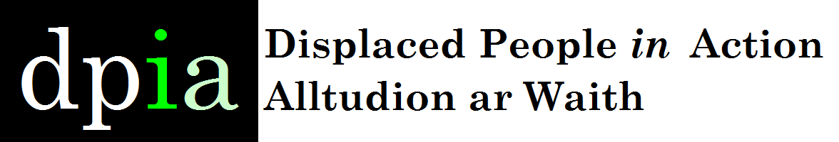

Displaced People in Action (DPIA) is a registered charity that has been helping refugees
and asylum seekers integrate into their new lives in Wales since 2001.

We are proud to be working with several Local Authorities across South East Wales as delivery partners to provide key Support and Orientation services to those families and individuals which are being relocated under their participation in the following UK Government backed schemes:

SYRIAN VULNERABLE PERSONS RELOCATION SCHEME
AFGHAN INTERPRETERS RELOCATION SCHEME

DPIA are now advertising for the following vacancies:

CASE WORKER (FIXED CONTRACT HOURS)
Initially for 3 days per week (possibility of increasing to 5 days)
Full time equivalent salary £21,000
Post is initially for 1 year and carries an 8% employer pension contribution

SESSIONAL / RELIEF CASE WORKER (VARIABLE, NON GUARANTEED HOURS)
Hourly rate £13.75

APPLICATION DEADLINE 31st MARCH 2016

To request further details please email jobsdpiawales@yahoo.co.uk quoting the reference RELOCATION

We are an Equal Opportunities employer.
Charity Registration Number 1117456
Company limited by guarantee 5966788

